**Bandit Level 5**

“The password for the next level is stored in the only human-readable file in the **inhere** directory. Tip: if your terminal is messed up, try the “reset” command.”

I entered the command cd inhere then ls -la

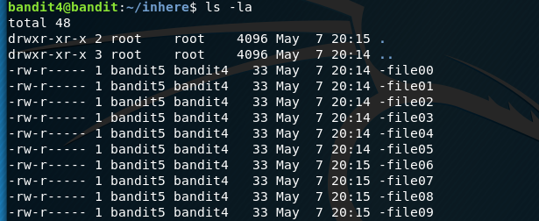

I noticed the file had a -file00

Then I entered the command:



Almost there!

Now I must search all files and see what one has the password



File 7

Storing password here:

koReBOKuIDDepwhWk7jZC0RTdopnAYKh

Logging into Bandit 5:

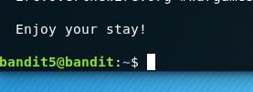Success!